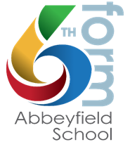
OPTION BLOCKS: SEPT 2024

BLOCK A | BLOCK B | BLOCK C | BLOCK D
Business A-Level | *Maths | Chemistry | Biology
English Literature | Performing Arts CTEC | English Lang | Geography
Criminology (Applied A-Level) | Psychology | Economics | Photography & Art
Physics | Sociology | Philosophy & Ethics | History

BLOCK E: Core Maths, EPQ, Skills for Work and Life, Further Maths PLUS Spanish.

Core Maths AS, Skills for Work and Life, *Further Maths AS and EPQ are also outside the option blocks and are taken as an additional subject in Year 12 (CM, Work Skills, EPQ) / Year 12 & 13 (FM)
*must be taken in conjunction with Maths A-Level

If you wish to study 4 A-Levels, or an additional subject as AS only please contact Miss Jones to discuss: sxj@abbeyfield.witls.sch.uk

